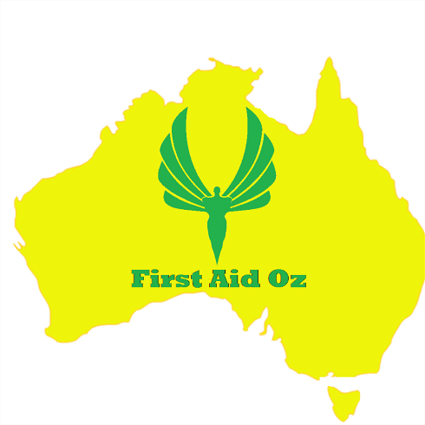

HLTAID014 Provide Advanced First Aid

Practical Assessment Task 3

Students are to demonstrate their knowledge in skills in the use of the following first aid items of equipment :

Item of equipment | Typical scenario where it can be applicable | Demonstrated competence in simulated scenario
roller bandages
triangular bandages cloth
trauma dressings
placebo bronchodilator and spacer
Adrenalin auto-injector
back boards and stretchers
AED training device
thermometer
emergency rescue blanket
eye patch

