Case Study 4

Instructions to student:

You must select from one of the following case studies to base your assessment on. Once you have chosen which case study to use, you will be required to answer the following questions in relation to the client in the case study.
If you require additional information regarding the client’s history please contact your trainer, or alternatively you can use your discretion to add notes to the clients file, but ensure you include these details in your submitted assessment.

See next page for case study options 1 and 2, and questions to complete.Case study - Option 1

Global Massage Institute - Massage Therapy Clinic

Section A: PATIENT TO COMPLETE THIS SECTION

PERSONAL INFORMATION PHYSICIAN INFORMATION

Name: Natalie Pain Name of physician: Jack Olive
Date of birth: 21/06/1983 Address: Richmond Medical Clinic
Occupation: Administration / office worker
Address: 35 Baby Street Richmond
Telephone: 9785 2556 Telephone: 9785 9999
Work: N/A

Please indicate your area(s) of pain
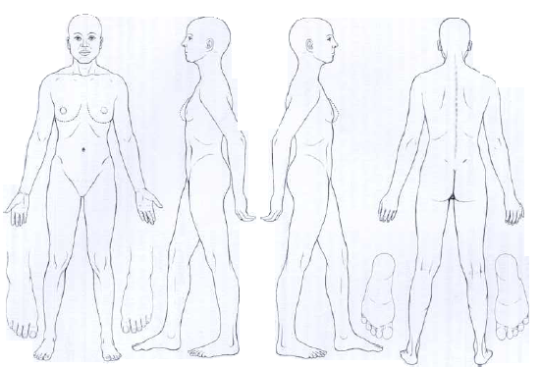
X
X
X
X
X

Have you had or do you suffer from any of the following:

Blood pressure:
Heart or circulatory disease______________
Malignancies_________________ Recent fracture: tibia (6 months ago)
Spinal disorders_______________
Systemic disease______________________
Inflammation__________________ Pregnancy: 10 weeks, second pregnancy
Varicose veins_______________ Other_______________________________

PERSONAL DETAILS:

Allergies: Peanut allergy
Current medical treatment/medication:
Panadol, no medical treatments as yet
Skin conditions: none
Surgery none

DETAILS OF THE PATIENT’S PRESENTING COMPLAINT
Patient presents complaining of :
- Aching lower back, worse when stiff, better with heat and stretching
- Headaches – regular, having them every other day, sharp pain radiates into upper neck and shoulders
- Paid radiating from buttocks into back of the knee, worse after work
- Tibial fracture occurred 6 months ago, running aggravates pain , burning pain

Patient walks into room with a limp, favouring right leg

As patient is talking you notice she winces when talking about her condition

Palpation of LB region – no noticeable abnormalities, muscle tightness
Palpation of tibialis anterior – heat and inflammation?

PATIENT TREATMENT HISTORY Leisure/Sport Activity
No treatment for any of the complaints  Uses over the counter medication for pain relief | Runs 3 x a week – 5kms. (reduced after fracture 6 months ago, slowly increasing pace from a walk since)  Works in an office at a desk 5 days a week

Option 2
Global Massage Institute - Massage Therapy Clinic

Section A: PATIENT TO COMPLETE THIS SECTION

PERSONAL INFORMATION PHYSICIAN INFORMATION

Name Gregory Bird Name of physician Dr Sonya Brush
Date of birth 15/06/1960 Address Cranbourne West Medical Centre
Occupation Painter
Address 18 Dulux rd, Cranbourne
Telephone 9652 5896
Telephone Home 9652 3333

Please indicate your area(s) of pain
X
X
Do you have or have you ever had any of the following:

Blood pressure: high 140/95_______ Heart or circulatory disease______________
Malignancies_________________ Recent fracture________________________
Spinal disorders:

Systemic disease______________________
Inflammation: __________________ Pregnancy___________________________
Varicose veins_______________ Other_______________________________

Section B: THERAPIST TO COMPLETE

PERSONAL DETAILS:
Allergies: no known
Current medical treatment/medication: none
Skin conditions psoriasis over back
Surgery none

DETAILS OF THE PATIENT’S PRESENTING COMPLAINT
Patient presents with burning pain in the shoulders and upper back region. Has been a painter for 30 years, owns his own business.

Pain is worse in the afternoon after work, and is relieved by rest and hot showers, massage etc

Pain has been present for the last 5 years, frequency is increasing lately. Pain causes severe headaches.

Client is overweight, always tired and lethargic, and seems to be quite irritable

Upon further questioning, client seems to have quite an unhealthy diet, no breakfast,first meal at 1pm- sausage roll or pie with Big M milk drink, next meal dinner – large pasta or takeaway, lots of coffee an soft drink.

PATIENT TREATMENT HISTORY Leisure/Sport Activity
Patient visited an osteopath a few years ago but had limited relief so stopped treatments.  His wife keeps buying him different vitamins or health shakes but he forgets or doesn’t want to take them | No regular exercise activity

Questions:
You must answer the following questions in relation to the client assessment details given in your chosen case study. Completion of these questions will form part of the assessment for this unit.

Assume you are a therapist in a new Massage clinic.
You receive a new client; this client has not received treatment from your clinic previously, and they are seeking treatment for their presenting complaint. Your initial consultation has been documented above.

You are to answer the following questions.

1. What would your initial assessment of this client contain? (Include assessment techniques you would use, additional questions to obtain further information etc)

2. a. Are there any contraindications present in this client that would prohibit them from receiving a massage treatment?

b. If yes, list all contraindications and explain why they are a concern.

3. a.Of the presenting complaint your client has given and taking into account all of the case history, what assessment and/or treatment principles would you prioritise when approaching the treatment plan? Why? (Discuss adherence to treatment plan, contraindications etc)

b. Create a treatment plan (attach)

4. Assume you need to refer this client to another allied health professional for further care and treatment. (Choose allied health professional of your choice)
Write a referral letter to this allied health professional with all relevant details. (You may need to refer to previous unit of competency HLTCOM406C- Make referrals to other health care professional’s where appropriate)

5. Divide the signs and symptoms given by the client, into the following table, differentiating between a sign and a symptom.

Definition of a sign: ____________________________________________________________________________________________________________________________________________________________________________________________________________________________________________________________________________________________________________________________________

Definition of a symptom:
____________________________________________________________________________________________________________________________________________________________________________________________________________________________________________________________________________________________________________________________________

Complete following table:
SIGNS | SYMPTOMS

6. After you have assessed and treated this client for the first time, they ask you to write them a letter summarising your assessment and treatment plan for their own records.

You are to write a brief letter, using easy to understand language for the client to take with them, including your rationale for treatment, reason for referrals, etc.

This letter should be no more than 200 words, and use limited medical terminology in order for the client to understand the language used.

