Case study 3

Beck is an 18-year-old client of yours. She is usually very cheerful and optimistic and has been seeing you because she needed assistance with lower back discomfort. She has an active social life, is very involved in sports and her local community. She is part of a loving and supportive family.
Today she arrives 20 minutes early for an appointment and is crying in the waiting room when you come to call her in. She is hesitant to tell you what has happened to her.
You will need to persuade Beck to talk to you.

1. Write in the space provided some questions you could ask her. Include open-ended, closed and reflective questions.
_____________________________________________________________________________________________________________________________________________________________________________________________________________________________________________________________________________________________________________________________________________________________________________________________________________________
______________________________________________________________________________________________________________________________________________________________________________________________________________________________________________________________________________________________________________________________________________________________________________________________________________________________________________________________________________________________________
_________________________________________________________________________________

2. After talking with Beck, you ascertain that she has been abused by a male family member.
Beck tells you that she still wants to have her massage treatment.

Detail the preparation required before treating this client. Include the following:
- Draping
- Assessment
- How you would respect client boundaries
- Client feedback
__________________________________________________________________________________________________________________________________________________________________________________________________________________________________________________________________________________________________________________________________________________________________________________________________________________________________________________________________________________________________________________________________________________________________________________________________________________________________________________________________________________________________________________________________________________________________________________________________________________________________________
_____________________________________________________________________________________________________________________________________________________________________________________________________________________________________________________________________________________________________________________________________________________________________________________________________________________

3. Using the assessment form as attached as Appendix A, create the notes for Beck’s consultation. Attach this report to your assessment.
Include recommendations, suggestions, referrals etc.

Appendix A

Global Massage Institute - Massage Therapy Clinic

Section A: PATIENT TO COMPLETE THIS SECTION

PERSONAL INFORMATION PHYSICIAN INFORMATION

Name: Name of physician:
Date of birth: Address:
Occupation:
Address:
Telephone: Telephone:
Work:

Please indicate your area(s) of pain
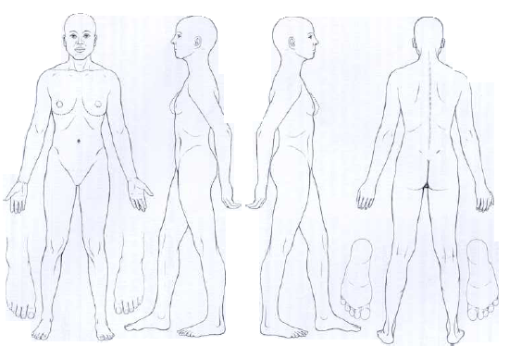

Have you had or do you suffer from any of the following:

Blood pressure:
Heart or circulatory disease______________
Malignancies_________________ Recent fracture:
Spinal disorders_______________
Systemic disease______________________
Inflammation__________________ Pregnancy:
Varicose veins_______________ Other_______________________________
PERSONAL DETAILS:

Allergies:
Current medical treatment/medication:
Skin conditions:
Surgery

DETAILS OF THE PATIENT’S PRESENTING COMPLAINT

PATIENT TREATMENT HISTORY Leisure/Sport Activity

