HLTMSG002 Assess client massage needs
Practical assessment

Trainer Instructions:

The student must demonstrate during the scheduled class, the ability to select therapeutic principles to determine treatment, and discuss the treatment strategy with the client.
You will be required to complete the appropriate trainer observation checklist for all students in the class by ticking the appropriate response, once the student has demonstrated appropriate competence.

In class:
- You will be required to divide the class into two (2) groups (therapists and clients).
- You will need to hand out a case study card to the simulated client group. The “client” is required to advise student “therapist” of condition as per their case study card.
- The “therapist” will need to plan a treatment strategy and discuss this with the client as per checklist below
- Appendix A – sample treatment record form, to ensure student covers all criteria in plan

Student Instructions:

Your trainer will divide your class into 2 groups, you will be assigned a simulated client who will present with a particular condition that you will need to assess and create a treatment plan for.
Please see Appendix A for a sample treatment record to ensure you cover all required criteria in your assessment and plan.

You will need to submit the assessment notes, and treatment plan, with the trainer observation checklist, to be assessed as competent for this unit.

You will be given approximately one (1) hour to complete this task, and then you will swap roles and become a client for another student.

Practical Demonstration
You will need to demonstrate to your trainer your ability to select therapeutic principles to determine treatment for your client, and discuss the treatment strategy with the client.
You are required to ‘assess and develop a treatment plan’, for a fellow student with a specific condition that is selected by the trainer (on a case study card), and ensure you follow the correct procedure in assessing and formulating a treatment plan.

Your trainer will observe you to assess your ability to:
- select therapeutic principles to determine treatment for your client
- discuss the treatment strategy with the client.

The trainer will complete an observation checklist and it will form part of the evidence gathered for this unit.

Appendix A

Sample Treatment Record
MASSAGE TREATMENT RECORD – Initial assessment form

Student Name: ________________________________________

Client’s Name:……………...…………………….………………

SUBJECTIVE EXAMINATION
Patient Complains of:

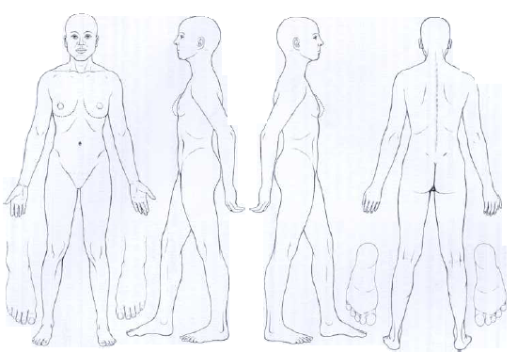

Notes: This includes all the things the client tells you about how they are feeling, past history, present symptoms, limitations in their lives due to the injury, what makes them feel better or worse, and details about the initial onset of the problem or injury.

Questions:
- Have you ever had a massage? If so what type? or by what therapist?
- Are you taking any medications like pain relievers or blood thinners?
- Do you have any heart problems?
- Are you allergic to any oils or nuts?
- Occupation/activity?
When someone is in pain:
- Where is the pain exactly? Have client point or fill out body chart to pinpoint location
- When did it start?
- Did you have it before? When? What did you do to relieve it?
- Are you seeing other health care providers like physical therapists, acupuncturists, Naturopaths, chiropractors, sports medicine physicians?
- How did it start? With traumatic injury? Just came on over time?
- What makes it feel better?
- Does it cause other pain in other areas?
- What kind of pain is it? Aching, sharp? other?
- Is there anything that makes it better or worse?
It is often helpful to ask the client to rate their pain or discomfort on a level 1-10 with 10 being the worst. If you do this each time, you will be able to see improvements or setbacks.
Pain: location, intensity, duration and frequency of the pain or discomfort. How long have they had it? Hours? Weeks? Months? Longer? Has it been worse or better? What makes it worse or better? How often do they get it? Every day? Once a week?
What do you hope to get out of today’s session?

OBJECTIVE EXAMINATION
Observation:

Assessment of Client:

Treatment plan:

Student Name: __________________________________________________ date : _________________

Signature: _______________________________________

