
SISXRES001 Conduct sustainable work practices in open spaces
Learner Guide
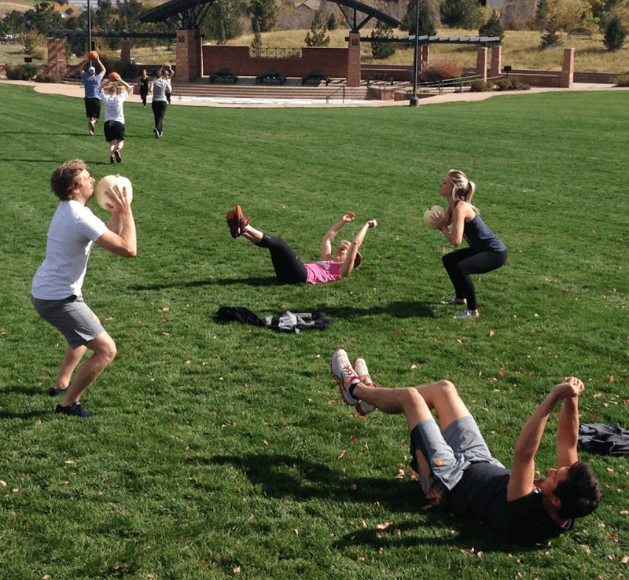
One of the major growth areas in the fitness and recreation industry is the delivery of exercise programs in open spaces, such as parks, on sporting ovals, beaches and on bush trails.
Some trainers even deliver programs in their yard or out in the street, community playgrounds and athletics tracks.
Parks and open space refers to land that has been reserved for the purpose of sport and recreation, preservation of natural environments, provision of green space and/or urban stormwater management.
Parks and open space vary in size, form and the range of functions that they perform. Public open space is usually categorised into a hierarchy including neighbourhood, district and regional open space and may perform either a passive or active recreation role.
The benefits of getting out in the fresh air to exercise are many, as are the potential hazards and planning factors that need to be taken into consideration.
The provision of suitable parks and open space can contribute to people meeting Australian physical activity recommendations of at least 60 minutes of moderate to vigorous activity for children and adolescents each day and 30 minutes of moderate intensity recreation activity on most days of the week for adults.
Of course, with the massive increase in use and popularization of open spaces, local governments have had to meet this trend with the introduction of policies and guidelines around the use of the facilities.
Some councils have responded to the increased needs by installing fitness stations around jogging/walking tracks, improving bike paths, increase in public amenities in parks (drink taps, toilets, etc).
Of course, the grey area in the provision of these traditionally free services to the rate payers of their community is the increased commercial use by trainers to conduct exercise for monetary gain, without necessarily contributing to the cost of the maintenance.
Prior to offering your training services in a public space, you need to check with the local council on what their specific policy is in regard to you conducting your business on what is effectively their land. This case vary from municipality to municipality, so best to be clear from the outset.
You need to be aware of local government codes of practice and permitted use policies, as well as industry codes of practice, when it comes to outdoor training.
There will often be paperwork required to outline what you are doing and when, what areas you are planning to use. You may need to provide copies of Public Liability insurance, business registration and even evidence of your qualifications. In some cases, there may be a cost involved for the commercial use of the space, which is not unreasonable.
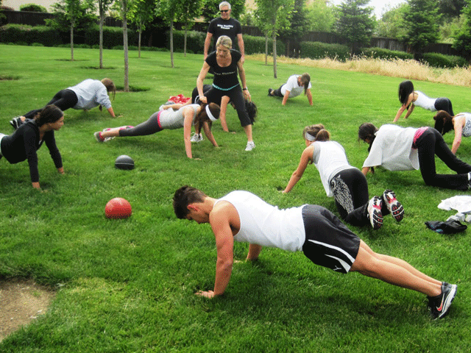
Naturally, with the increased tendency towards litigation against the local government for injuries incurred on public land, where this injury happens during one of your paid sessions, then the trainer is also at high risk of litigation.
If you are deemed to be using the land without notification and permission of the local authority, without the necessary insurance coverage or the necessary formal skills, then the outcome could be catastrophic to your bottom line.

Open space within the local community
As mentioned, there are a myriad of potential open space areas that can be used for exercise and recreational activities. These include, among others:
- Walking tracks
- Bicycle paths
- Parks
- Playgrounds
- Sporting ovals and courts
- Nature reserves
- Beaches
- National parks
- Mountains
- Forests
- Car parks
- Public squares and picnic areas
- Skate parks

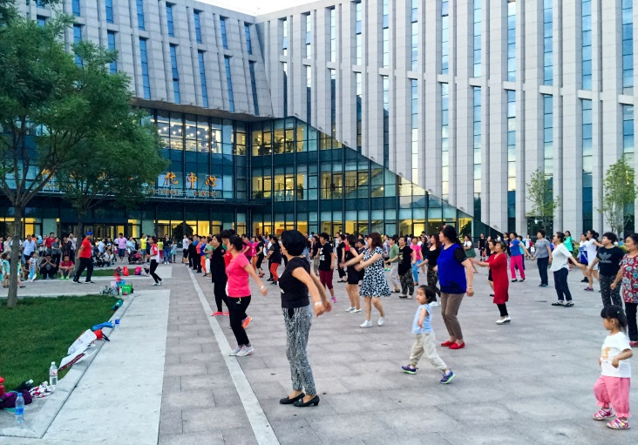
Permitted use of public space
Many of these areas are freely accessible to members of the community for their passive recreational use, including personal exercise or self-training.
In many cases, there are signs up at public spaces which often outline what is permissible or not in that area.
When it comes to the commercial use of these spaces, however, one must be aware of the law of the land.
Local Council policies
Each local council will have their own guidelines and policies on the permitted commercial use of their public space. A trainer wishing to conduct business there must be aware of these. It is not as simple as just going for a drive and conducting a session, where you are charging for the service.
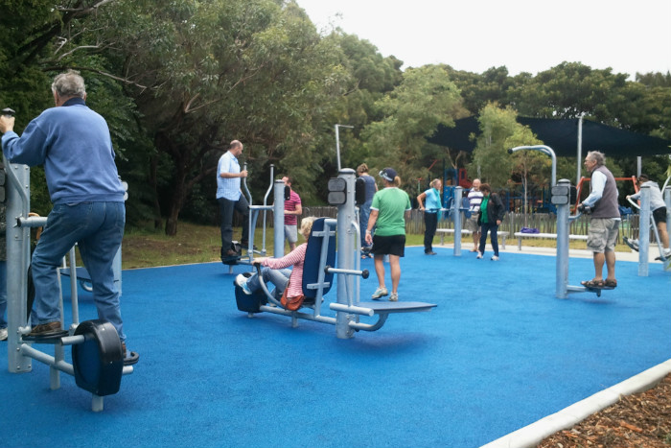
The main areas of concern to local government and statutory authorities with respect to use of public land by commercial fitness operators are:
1. Equity of access to open space
2. Impact on assets
3. Safety and Public liability concerns
4. Administrative burden

Industry Code of practice
Whilst there are others, the largest industry body when it comes to Fitness is Fitness Australia.

Fitness Australia acknowledges that public land is an important asset which is held in trust for
the community.

Through the Fitness Industry Codes of Practice and Professional Ethics, Fitness Australia gains commitment from business owners and professionals that they will meet all legal obligations, operate within their scope of practice and carry out their operations in an ethical manner.

In the case of delivery of commercial fitness services on public land, this requires all fitness operators to:
1. hold a current Exercise Professional Registration with Fitness Australia
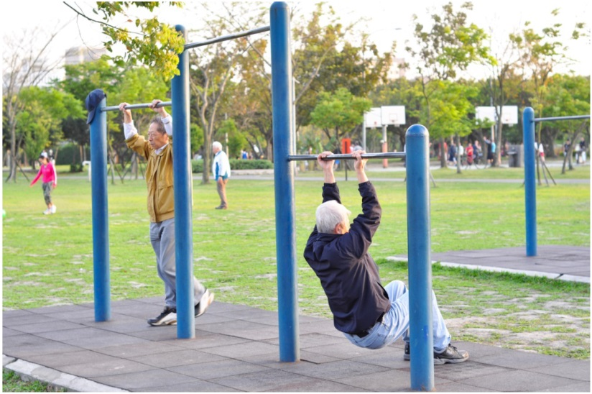
2. gain the consent of the Council for access;
3. hold an appropriate permit/licence;
4. abide by specified conditions; and
5. pay fees to support the permit/licence system.

Note: It states in the National Fitness Industry Training Package that a trainer must have completed Certificate IV in Fitness (Personal Training) to be qualified to work outdoors in an uncontrolled environment.

Minimal Impact activities
In order to preserve the condition and ambience of open spaces, for the passive enjoyment of the community, it is imperative that the commercial use of this land does not compromise this aim.
Considerations need to be made in the areas of :
Noise/Disturbance

Commercial fitness training activity operators must:
• be considerate to other reserve users and adjacent residents;
• not create any noise from training activities that unreasonably disturbs other users and adjacent residents;
• ensure that all noise associated with their activities does not cause offensive noise as defined by the relevant State or Territory Environment Protection Legislation.
• ensure that exercise equipment used does not create any hazards or obstruction; and
• give way to pedestrians/cyclists when moving through narrow areas with groups (i.e. along footpaths, stair-ways and cycle-ways).

Hours of operation
Where facilities are in close proximity to residential areas, trainers need to be considerate of the noise and disturbance to local residence.
As many people conduct early morning or evening training, due to daytime work commitments, this is a real concern, particularly in the case of exercising in groups, or using music, whistles, yelling instructions and do forth.
Also in many cases, public land is only permitted for use between certain hours.
Permissible Activities
Outdoor fitness training activities should be limited to the scope of practice of a registered personal trainer, which would include but not be limited to the following activities:

• Strength-based and aerobic fitness activities (with or without free-weights, fitballs,
skipping ropes, medicine balls etc.)
• Non-contact boxing and pad training
• Organised aerobic activity (fitness and sports drills)
• Yoga, Tai Chi and Pilates activities
• Walking and running

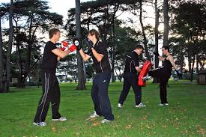
Prohibited Activities
With respect to equity of access and protection of the environmental asset, the following activities should be prohibited within public open space:
• Aggressive and intimidating activities that involves shouting, loud voice calls or instructions
• Activities in children’s playgrounds
• Groups containing over 18
• Dragging of logs, tyres, heavy ropes and other equipment that may damage the natural environment
• Any activity that is deemed to be aggressive or intimidating in nature whether real or perceived by participants or the general public
• Outdoor recreational activities conducted with amplified music or megaphones which cause offensive noise as defined by the relevant State or Territory Environment Protection Legislation.
• Soliciting of funds directly from park visitors or the public
• Erection of advertising signs, and banners, temporary or otherwise without Council’s written consent
• Erection of signs, stakes, rope or tape, temporary or otherwise without Council’s written consent
• Suspending boxing or kicking boxing bags or any other equipment from trees and/or structures in the reserves
• Utilising trees, seating, picnic tables, rotundas and other park infrastructure for exercise training

This list is not exhaustive and should be at Council’s discretion.

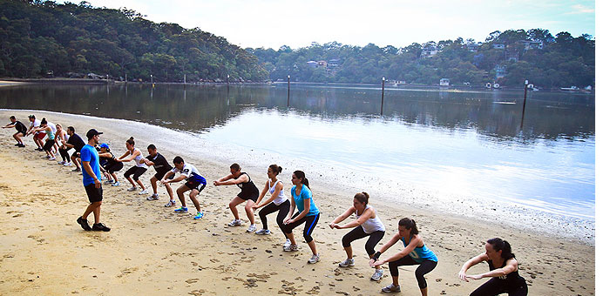

Planning considerations for the trainer
Apart from the legislative and industry requirements pertaining to the use of public or outdoor spaces for exercise, there are some practical considerations a trainer needs to take into account.
These include, but are not limited to:
- Suitability of space in consideration of the nature of activity and group size
- Adequate access to toilets
- Are there taps with safe drinking water
- Accessibility of area, is it easy to get to and safe to reach.
- Is there adequate parking available
- Does the area have mobile phone reception in the event of an emergency
- Do you have adequate first aid training for remote locations
- What equipment is required and are you able to get it there
- Does your location have a commonly recognizable name so you can describe to people where to meet ?
- Is it a safe area ? Consider snakes, other animals and other people
- Is there adequate lighting for early morning or evening sessions ?
- Are there shower and change facilities for people going to, or coming from work, to your sessions.

Environmental considerations
- What happens when it rains – is there a shelter available to continue the session
- What is the policy for hot weather, skin care, dehydration, heat stroke etc.

